Ch-2
Classification of animals
- Question answer –
- Look at the image and Point the differences and similarities between Mountain goat and Plain goat.
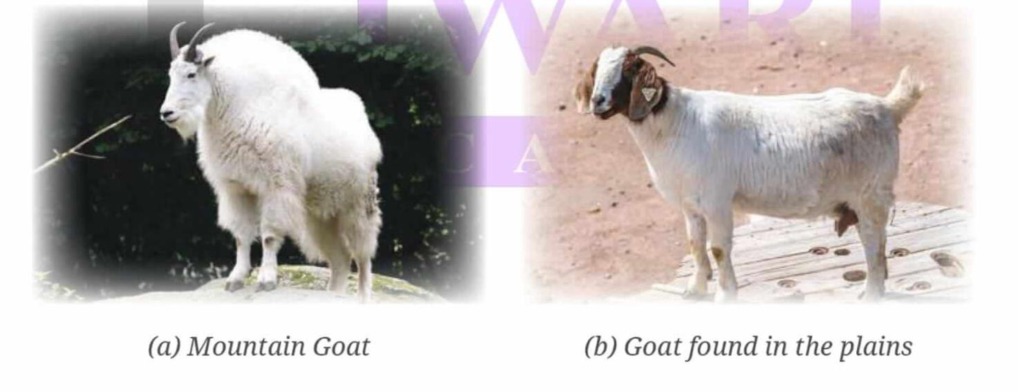
Ans- Difference-
- Mountain goat: They have strong hooves, strong muscle, thick fur which help them to survive in cold, rocky mountain environments. They also have sharp horns for protection against predators.
- Plain goat: They have thinner fur, a lean body which help them to adapt in warmer, flatter environments. They have short horns and long legs to run fast and escape predators.
Similarities- Both type of both have a similar diet i.e herbivores and our mammals.
- Different animals adapt to survive in different surroundings for example we can see some difference in the features of a camel of hot desert and cold desert. Mention the basic difference is between animal living in a hot desert and cold desert.
Ans-
Camel in hot desert (Rajasthan) | Camel in cold desert (Ladakh)
- Camels have long legs and white hooves to walk on sand without sinking. | - Camels in cold desert are shorter with short legs to walk easily on rocky mountains.
- They store fat in their single hum to survive food scarcity. | - They have two humps that shrink in winter due to use of stored fat.
- They have thin layer of fur on their body to maintain their body temperature in extreme hot climate. | - They grow thicker coats of fur to survive the extreme cold temperature.

- Your friend shows you a small warm like creature that has a long body without legs and lives in the soil. To which group does this creature most likely belong?
- You were watching a documentary and seen an animal that gives birth to young ones.
  - In which group does this animal belong?
  - Write down two more characteristics for this group of animals.
  - On the basis of reproduction, is this animal oviparous or viviparous? Justify your answer with a proper reason.

